DAVID BOERNER
ECONOMICS 2301
“SKELETON” CLASS NOTES

SECTION 2

UNEMPLOYMENT AND INFLATION

Employment Definitions (Remember population pool in question is all individuals 16 yrs old and over

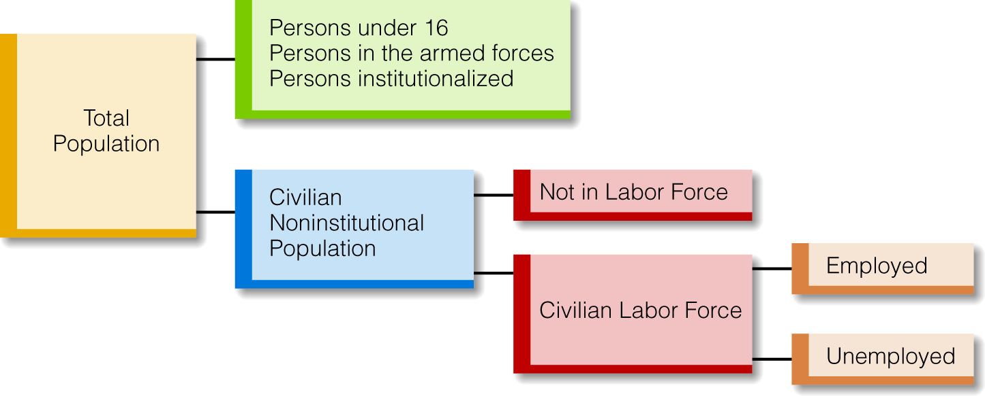

Employed – people working.

Unemployed – people not working but actively seeking work.

Labor Force – employed + unemployed

Not in the Labor Force – people not working and NOT looking for work.

Discouraged workers – Individuals not actively seeking employment because they feel there is no hope in finding work. Not counted in the unemployed

Important factors in severity of unemployment:
Duration of Unemployment – the overall average duration illustrates the severity of the unemployment situation.

Labor Force Participation Rate – Percentage of noninstitutionalized working-age individuals who are employed or seeking employment
Calculating the Labor Force Participation Rate

LF% = (#Labor Force)/(#Population 16 yrs & Older) x100

Unemployment Rate – the percentage of the labor force that is unemployed.

Calculating the Unemployment Rate

U% = (#unemployed)/(#labor force) x100

Example:

#in labor force = 20,000

#unemployed = 1000

U% = 1000 / 20,000 x 100 = 5%

Types of Unemployment

Frictional

Structural

Cyclical

.

Frictional Unemployment

People voluntarily leaving a job for the purposes of seeking better opportunity elsewhere
- This type of unemployment is actually positive for the economy.

Structural Unemployment

Employers, reacting to changing market conditions and changes in technology, eliminate jobs.

Results in skilled workers with no job to match that skill.
- Unlikely these jobs will return, even if economy improves.
- Not affected significantly by Aggregate Demand fluctuations

Cyclical Unemployment

Caused by layoffs as the economy enters into a recession. (Aggregate demand is insufficient to create full employment.

Full Employment

This is the macroeconomic goal.

Only frictional unemployment and structural unemployment exist.

Cyclical unemployment is zero.

Also called:

Natural Rate of Unemployment

NAIRU (non-accelerating inflation rate of unemployment)
- May not be constant value over extended period due to changes in structure of the economy & society.

Inflation and Deflation

Inflation – rising general level of prices. Price Index rises. Purchasing power of money decreases.

Deflation – falling general level of prices
- Purchasing Power – The total quantity of good & services which a specific amount of money will buy. Compare the nominal value of a dollar (current value) its with the real value (the quantity of goods & services it will buy). Compare purchasing power of a currency over time.

Price Index

A measure of the price level of a specific “basket” of good in one year in comparison to a price index of 100 in the base year (the price of the same specific “basket” of goods in the base year). The base year is the year chosen as the reference point for all future comparisons.

Computing a Price Index:

- (this year’s) Price index = (cost of market basket today/cost of market basket in base year) X 100

Example: Cost of market basket in 2014 - $1,650
Cost of market basket in base year 2005 - $1,400
($1,650/$1,400) * 100 = 117.86

How to compare effects of inflation over time:

PI_{most recent yr} /PI_{older yr}=Basket price _{most recent yr}/Basket price _{older year}

Example 1:

X/100 = $3300/$3000

X = (3300 x 100)/3000

X = 110

PI in the current year is 110.

A PI of 110 indicates that prices in the current year are 10% higher than prices in the base year.

Example 2
PI 2008 = 125
Basket Price 2008
PI 2012 = 150
Basket Price 2012 = X
150/125 = X/$2000

X = $2,000(150/125)
X = $2,400

Real World Price Indexes

Consumer Price Index (CPI) – measures the change in prices of a specified set of goods and services purchased by typical consumer in urban areas
Limitations:
- CPI does not take into account that consumer change purchasing choices as prices change – basket stays the same.
- CPI does not take into account improvements in product quality, which might be reflected by price increases.

Personal Consumption Expenditure Index (PCE) – measures the average prices that uses annually updated weights based on surveys of consumer spending.

Producer’s Price Index – measures the change in prices of goods and services that firms produce and sell.

GDP Deflator – measures the change in prices of all new goods and services produced in the economy.

Other Important Definitions for this topic

Disinflation – prices are rising but slower than before

Hyperinflation – out of control inflation

Stagflation – simultaneous rising inflation, rising unemployment, and a stagnant GDP (no economic growth)
- Nominal Rate of Interest –Rate of interest paid on current market transactions

Real Rate of Interest – The nominal interest rate minus the anticipated inflation rate.

Nominal Income – Income measured in that year’s dollars (current dollars)

Real Income – Nominal Income adjusted for price changes

Impact of Inflation:

Borrowers are able to pay back loans in lower valued dollars.

Lenders add an inflation premium to the interest rate, so interest rates rise.

People on fixed income suffer a decreased standard of living.

Savings lose value.
- When the actual inflation rate is greater than what was expected, creditors lose while debtors gain.

Business Cycle

The sequence:

Peak, contraction/recession, trough, recovery/expansion, peak

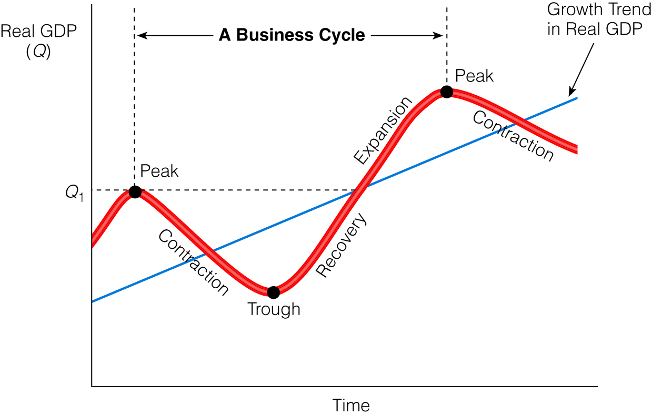

The long-run trend is up for economic growth.
- Short-run fluctuations occur and cause problems due to rises in unemployment or in inflation.
- Historically, the recession phase is short and the recovery/expansion phase is long.

Business Cycle Terms
- Business fluctuations – The ups and downs in business activity throughout the economy.
- Expansion – A general increase in the level of business activity in the economy.
- Contraction - A general decrease in the level of business activity in the economy.
- Recession – A period of time in which the general level of business activity in the economy is less than its long-term trend.
- Depression – An extremely severe recession.

Characteristics of each phase of the Business Cycle

Peak

Highest real GDP in the cycle

Unemployment low

Inflation may be a problem

Contraction/Recession

Real GDP decreases quickly

Unemployment rises rapidly

Inflation lessens
- Production falls

Trough

Lowest real GDP in the cycle

Unemployment high

Inflation usually not a problem

Expansion/Recovery

Real GDP increases slowly

Production rises

Unemployment falls slowly

Inflation may begin to increase at the end of this phase

The unemployment rises fast going into recession, but falls more slowly as we come out of a recession. This is because employers are reluctant to add workers until business picks up.

MEASURING ECONOMIC PERFORMANCE

We use a National Income Accounting system to measure aggregate economic activity in a county or other political entity

National Income accounting is based on a Circular Flow of economic activity.

Circular Flow

Two markets:

Product Market – Businesses sell final goods and services to households. The payment from households become the businesses’ income.
Final goods and services – goods that are in the final form and will be used by the end consumer (bread as compared to wheat)

Factor Market – Factors of production(workers, landowners, capital owners, and entrepreneurs – consider all as households) sell their services to businesses for use in businesses’ production process. Payments from businesses to factor of production owners are income (wages, rents, interest and profits respectively).

Gross Domestic Product (GDP)

The total market value of all final goods and services produced annually in the country.

Key points in the GDP definition:

measured in $ (could be in current (nominal) $ or inflation adjusted (real) $)

intermediate goods not included

only American production

non-market activity not included

work done by family members not included

used goods not included (value of Second Hand goods not included, only the value added in the final sale)

illegal underground activity not included

transfer payments are not included (payment, but no current production)

legal underground activity (cash transaction which are not reported for income tax) not included

buying/selling of financial securities (only transactions fees & services are current GDP activities)

Remember - GDP is a measure of the value of economic activity (value of goods & services produced), not a measure of an economy’s overall welfare or social health.

Two methods for calculating GDP

Expenditures Approach – (Adding up dollar values at current prices of all American-made final goods and services)

GDP = C + I + G + X

C = Consumption spending

I = Business Investment spending

G = Government spending

X = Net Exports (Exports – Imports)

Expenditure Components

Consumption Spending (C)

Largest category

Durable goods [goods that last at least 3 yrs](most volatile)

Non-durable goods (goods used up within 3 yrs)

Services

Business Investment Spending (I) (Gross Private Domestic Investment)

New capital goods

for expansion

to replace worn out capital goods – (depreciation) (often referred to as Capital consumption allowance)

(heavily dependent upon interest rates and projected return on investment (ROI))

New residential housing

Investment in inventories (most volatile) – change in quantity of finished goods and raw materials

Government Spending (G)

All levels: federal, state, and local

Includes purchases of goods and services

Includes wages for government workers

Does not include transfer payments

Net Exports – (Exports (X) minus Imports (M))

Exports (X) - Foreign spending on American-made goods and services

added to GDP

Imports (M) – American spending on foreign-made goods and services

subtracted from GDP

Net Exports = (X – M)

Income Approach

Remember, since the economy is a “circular flow” we can measure economic activity by looking at the income generated in the economy.

Households receive Income (wages, interest, rent and profits) as payment for the resource they own.

What households do with their Income (Y)

They spend: Consumption (C)

They save: Saving (S)

They pay taxes: Taxes (T)
A useful calculation from the Income analysis is Disposable Personal Income (dY)
Disposable Personal Income: Personal income after income taxes have been paid. It is the amount households actually have to spend & save

Recap of the Circular Flow

GDP measured by the income approach equals GDP measured by the expenditures approach.

Business revenues (GDP) become business costs.

Business revenues come from C, I, G, and X.

Business costs become household income (Y).

Household income is spent (C and M), saved (S), and paid in taxes (T).

GDP = Y

GDP = C + I + G + (X – M)

GDP = Y = C + S + T

Y = C + S + T

Yd = Y – T = C + S

2013 GDP Data (in 2005 dollars)

GDP = $16.344 trillion

C = $ 11.211 trillion 68.6% of GDP

I = $ 2.033 trillion 12%

G = $ 3.726 trillion 22.7%

X – M = -$ -0.626 trillion -3.3%

Nominal GDP

Nominal means:

“as measured”.

“the effects of inflation are included”.

Each year GDP is measured by adding up all expenditures at the prices that existed in that year.

Nominal GDP cannot be used to compare production from year to year, since prices change. (change in Nominal GDP could be from increase in output of more goods and services, increase in prices, or some combination of both)
Real GDP

Real means:

“with the effects of inflation removed.”

Real GDP data can be used to compare production year to year, since the effects of changing prices have been eliminated.

For each year, we recalculate Nominal GDP from current year $ into base year $ to get Real GDP for that year.

To convert Nominal GDP (NGDP) to Real GDP (RGDP):

Real GDP_{year x}/Nominal GDP_{year x} = PI_{baseyear}/PI_{year x}

Example (for 1991):

Nominal GDP (1991) = 5677.5

PI (1991) = 117.8

therefore:

Real GDP/5677.5 = 100/117.8

Real GDP = 4819.9

Economic Growth

If Real GDP increases from year to year, there is economic growth.

Use the following formula to calculate economic growth:

= (Real GDP_{year2}–Real GDP_{year1}) x100/Real GDP_{year1}

Example:

- Real GDP_{year2 :} 3090
- Real GDP_{year1 :} 3000

growth = (3090 – 3000) / 3000 x100

= (90/3000) x 100 = 3%

Standard of Living

One measure of our standard of living is Real GDP/population, or per capita GDP.

This is the average amount of things produced per person in a year.

To raise the standard of living, Real GDP must grow faster than the population growth.

GLOBAL ECONOMIC GROWTH

Economic Growth – Increase in real per capita GDP on a year over year basis. It is Real GPD divided by population.
Per capita – per head (per person)

Issues with this definition:
- Real standards of living can go up without any positive economic growth (more leisure by working fewer hours, but producing as much as before.)
- Growth tells us nothing about the distribution of output and income.

Usefulness of the definition:
Measuring economic growth allow us to make comparisons across countries and time and provide a serviceable measure of productivity.
Potential Benefits and Cost of Economic Growth
Benefits:
- Improved literacy
- Reduction in poverty
- Improvements in public health & longevity
- Political Stability
Costs:
- Pollution
- Breakdown in the family and traditional social structures
- Increased urbanization
- Individuals feel increased isolation & alienation

WHY ECONOMIC GROWTH IS IMPORTANT:

Even small economic growth rates lead to sizable increases in the size of the economy over a number of years.

The Rule of 70 is useful tool to show how growth rates over time affect the speed in which economy & living standards grow – the key is compounding growth.

The Rule of 70: The approximate number of years required for per capita real
GDP to double is equal to 70 divided by the average rate of economic growth.

Example of the Rule of 70
- The average U.S. annual growth rate between 1990 and 2009 was 4.4 percent. This means that per capita real GDP would double every 16 years if that growth rate continued.
- China’s annual rate of 10.1 percent, per capita means that its real GDP would double every 6.9 years.

TRADITIONAL FACTORS BELIEVED TO LEAD TO INCREASED LEVELS OF ECONOMIC GROWTH
1. Establishing a System of Property Rights: The more certain property rights are, the more capital accumulation and economic growth there will be, other things being equal.
2. Developing an Educated Population: Developing countries can advance more rapidly if they increase investments in education.
3. Letting “Creative Destruction” Run Its Course: “Creative destruction” occurs when new businesses ultimately create new jobs and economic growth after first destroying old jobs, old companies, and old industries.
4. Limiting Protectionism: Open economies experience faster economic development than
do economies that are closed to international trade.
5. Productivity Increases: Labor productivity is real GDP divided by the number of workers (output per worker). Increases in labor productivity lead to increases in the standard of living.
6. Saving: Higher savings rates lead to higher living standards in the long run, other things equal, because investment and the capital stock will increase.
7. Population and Immigration: Population increases the labor supply, technological progress by increasing the number of geniuses, and by creating new spending that stimulates new businesses.

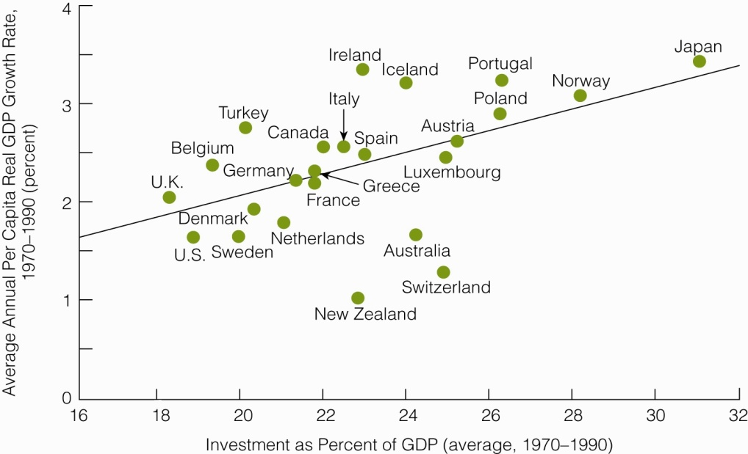

New Growth Theory and the Determinants of Growth: New Growth Theory examines how technology, research, and innovation are related to economic growth.
A. Technology Growth: Direct relationship between growth in technology and economic growth.
B. Importance of rewarding Technology: The greater the rewards provided for technological advances, the more technological advances we will get.
C. Research and Development: The rate of technological advance depends on the rate of spending on R&D. Business spending on R&D depends on expected profits. The greater the profit - the more R&D.
D. The Open Economy and Economic Growth: Open economies can & free trade encourages a more rapid spread of technology.
E. Innovation and Knowledge: Innovation involves transforming an invention into something that benefits the economy. Much innovation involves small improvements in the use of an existing technology.
F. The Importance of Ideas and Knowledge: There exists the possibility of an investment-knowledge cycle where investment spurs knowledge and knowledge spurs investment. Therefore knowledge, like capital, has to be paid for by forgoing current consumption. Knowledge can be viewed as a store of ideas. Thus, economic growth can continue as long as we keep coming up with new ideas.
G. The Importance of Human Capital: Increases in the productivity of the labor force are a function of increases in human capital. Human capital is at least as important as physical capital.

Modeling the Macro Economy

Long-Run Aggregate Supply (LRAS)

- The total of all planned production in the economy.
- Graphically it is a vertical line representing the real output of goods and services.

LRAS is:
- Full-employment GDP.
- Measured in base year dollars
- Equivalent to the Production possibility curve we have reviewed previously.
- Natural Rate of Unemployment GNP

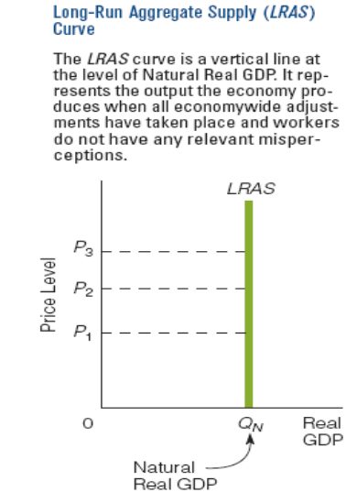

Growth and the LRAS curve.
As the aggregate economy grows (the Production Possibility Curve expands outward), the LRAS curve will shift outward
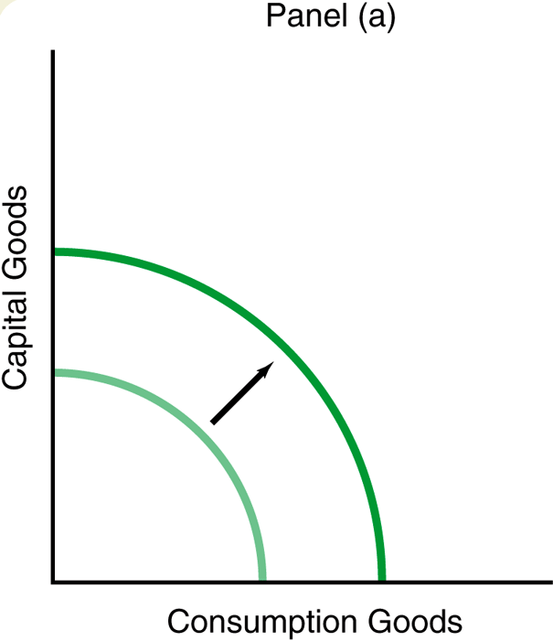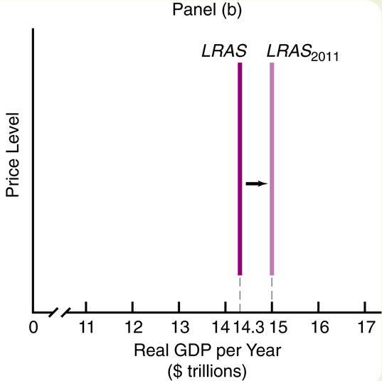

Aggregate Demand (AD)
- The total of all planned expenditures in the entire economy
- AD is a downward sloping line.
- As Price level (P) increases, Real GDP (Q) decreases, and vice versa.

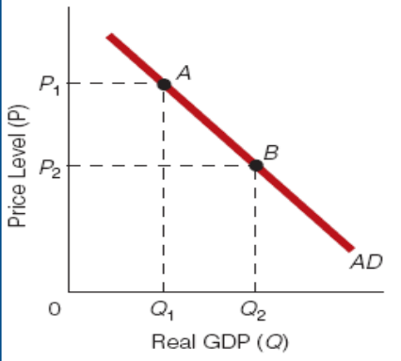

Reasons Why the AD curve is downward sloping:
- The real-balance effect - As price level rises, the purchasing power
of income and wealth falls, so buyers must buy less, and vice versa
- Interest rate effect – Higher price level increases the general
Interest rate which raises the cost for business and consumers to finance purchases, resulting in lower lever of purchases.

- Open economy effect Higher domestic prices lead to reduction in
quantity of domestic goods & services purchased. Exports fall, Imports rise.

Shifts in the Aggregate Demand (AD)

Any non-price-level change that increases aggregate spending (on domestic goods) shifts AD to the right. Any non-price-level change that decreases aggregate spending (on domestic goods) shifts AD to the left

- Aggregate Demand (AD) increases (shifts right) if:
- C increases (Increase in wealth, decrease in taxes)
- I increases (decrease in taxes)
- G increases
- X increases (increase in foreign income, dollar depreciates)
- M decreases (dollar depreciates)
- money supply increases
- interest rates decrease

- Aggregate Demand (AD) decreases (shifts left) if:
- C decreases (decrease in wealth, increase in taxes)
- I decreases (increase in taxes)
- G decreases
- X decreases (decrease in foreign income, dollar appreciates)
- M increases (dollar appreciates)
- money supply decreases
- interest rates increase

Long Run Equilibrium and the Price Level

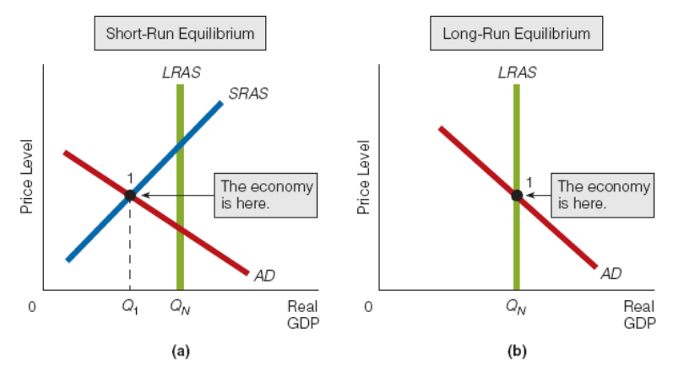

Understand how shifting LRAS and/or AD affect output and the price level

Deflation – a downward trend in general price level
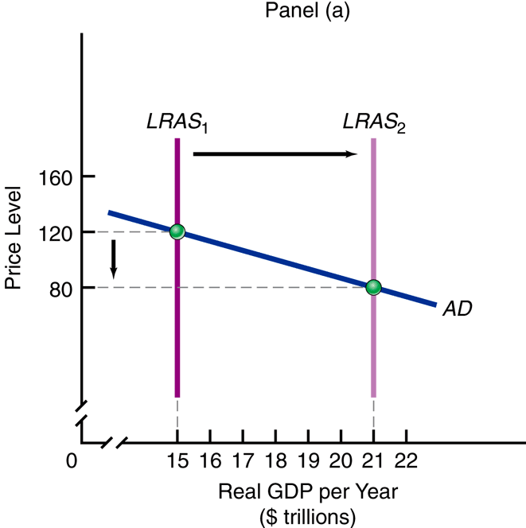

Inflation – an upward trend in the general price level

Cause of Long term Inflation
Demand – Side Inflation – AD grows faster than LRAS
Supply Side Inflation is highly unlikely over an extended period. It would require a decline in the long run aggregate supply, which has not historically been present.

INFLATION LONG-RUN PRICE STABILITY
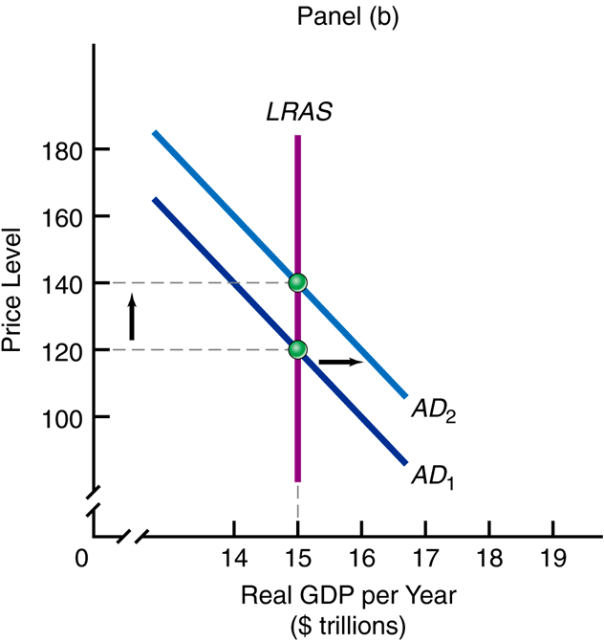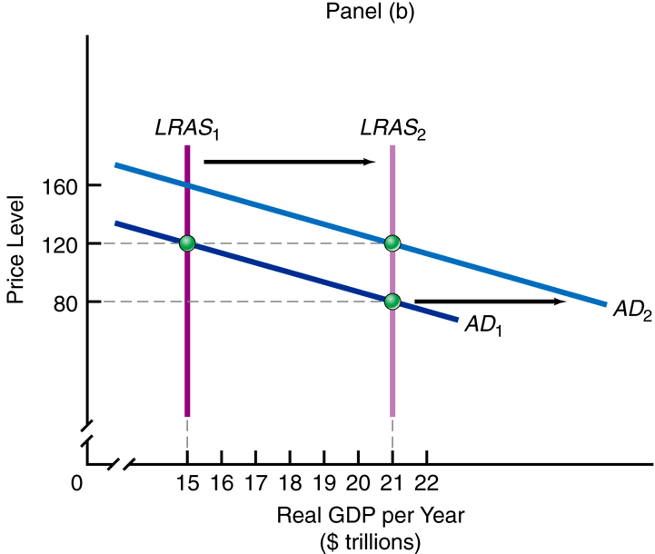

Classical & Keynsian Analyses

Can the economy, through rational expectations, work itself out of an overheated situation or an under performing situation … and get back to full-employment?
- If yes … laissez faire (no need for government involvement).
If no … need government involvement

Classical Economic Model

Classical Economic Theory was the principle way to look at the economy up to the Great Depression.

One of the foundations of Classical theory is an idea called Say’s Law

Say’s Law
- “Supply creates its own demand.” (The income from production will provide the funds to purchase the goods produced)
- Overproduction or underproduction cannot last long
- Buyers and sellers make necessary adjustments to better (or to protect) themselves.

Restatement of Say’s Law:
The market economy will adjust pricing and wages so that ultimately the production of any level of output of goods will generate the income necessary to purchase them

Classical Economics principles
- Pure Competition exists
- Individuals are motivated by self-interest
- The economy can “fix” its own problems.
- Laissez faire - Government need not interfere.
- Prices, wages, and interest rates are sufficiently flexible:
- upward to “fix” an inflation problem
- downward to “fix” an unemployment problem
- Product, labor, and credit markets will adjust sufficiently to “fix” all shortages and surpluses.
- There in no Money Illusion - People understand that increases in their income as a result of inflation has no effect on the real quantity of goods & services they can purchase.

What are the effects of savings on the long run economy?

Does the fact that individuals can save a portion of their income rather than spending it all lead to a leakage in the circular flow system? Does this mean that total planned consumption can fall short of real GDP?

How Classical Theory Viewed Savings

- Consumers’ savings provide a source of funds for business to access for investment.
- Therefore there is “money market” where the demand for funds (by business for investment) is matched with the supply of funds (consumers’ savings).
- There will be an equilibrium in this market based upon the interest rate (price of money). The market equilibrium interest rate will adjust to equate investment with savings.
- All of consumers’ savings will be used by business for investment. There is no net loss from the circular flow.

How the Interest Rate Equates Savings and Investment
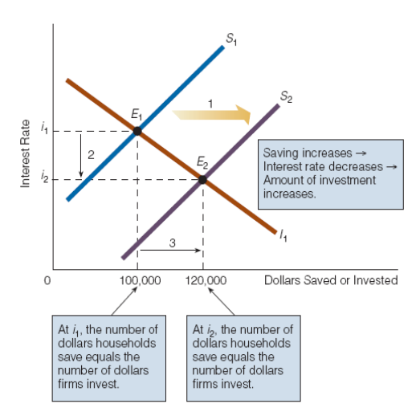

Labor Market Adjustments

- In the “labor market” individuals supply of labor is matched with business’s demand for labor.
- There will be an equilibrium in this market based upon the wage rate The market equilibrium wage rate will adjust to equate the supply of labor with the demand for labor.
- At the equilibrium wage rate all available labor will be employed by business.
- Since the wage rate is free to adjust at a rapid rate, there will always be full employment.

Classical Theory’s View of the Price Level and Aggregate Demand

- The various markets which compose the aggregate economy are able to adjust rapidly to any change.
- These rapid adjustments mean that the economy will react almost immediately to shocks and arrive at a new equilibrium.
- Since the economy will almost instantaneously be at a new equilibrium, the economy is basically always at full employment on the Long Run Aggregate Supply Curve
- Since the economy is always on its Long Run Aggregate Supply Curve (LRAS), changes in Aggregate Demand (AD) effect price level, not real production (real GDP).

The Keynesian Model of the Aggregate Economy

The Great Depression of the 1930s did not appear to be corrected by the market, as expected by the Classical Model. An English economist, John Maynard Keynes, developed a new view of how the aggregate economy works, especially when there is a downturn in the business cycle.

- In 1929-1932, the Great Depression occurred.
- Unemployment rose to 24 percent.
- Deflation occurred.
- Self-regulation could not cope with these problems.

- Classical Economics held that in a recession,
- Wages will fall (more will be hired)
- Prices will fall (more will be bought)
- The economy self-regulates, and
- Moves back to full-employment GDP

- Keynes’ criticism: In a recession,
- Wages would not fall. (Wages are “sticky” going down)
- Prices would not fall. (“sticky” downward also)
- Self-regulation could not occur.
- The economy could get “stuck” with high unemployment.

The Keynesian AD - AS Model of the Economy included a short-run supply curve which showed the economy could achieve equilibrium at less than full employment.

- The Keynesian model consists of:
- Aggregate Demand (AD)
- Short-Run Aggregate Supply (SRAS)
- Long-Run Aggregate Supply (LRAS)
- The vertical axis is Price Level (P)
- The horizontal axis is Real GDP (Q)

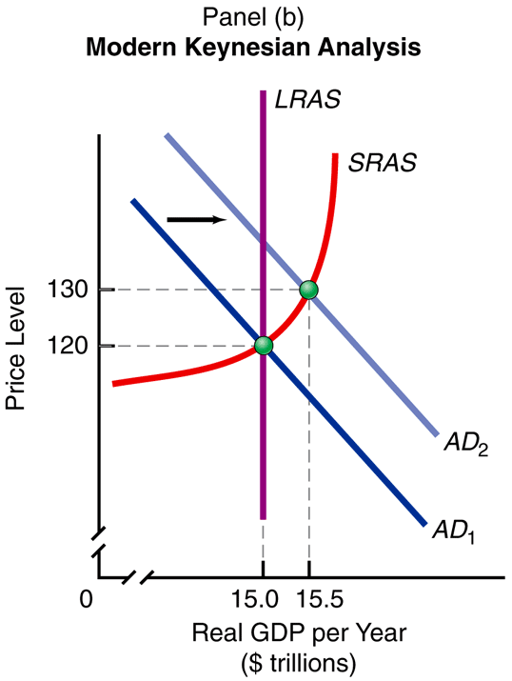

What the Keynesian Short-Run Aggregate Supply (SRAS) illustrates
- Initially, due to slack production & excess resources, the SRAS is horizontal (can increase output with no increase in price level)
- As production increases the SRAS becomes an upward sloping line.
  - As Price level (P) increases, Real GDP (Q) increases, and vice versa.
  - Rising prices generate a short-run increase in profit margins, spurring producers to increase production, and vice versa.
  - SRAS rises slowly at low levels of Real GDP.
  - Price level increases slower than Real GDP
- At higher levels of Real GDP output, the SRAS rises more steeply.

Price level increases faster than Real GDP

- SRAS increases (shifts right) if:
- production (input) costs decrease
- costs, including taxes, imposed by government decrease
- productivity increases
- there is a beneficial supply shock (unexpected decrease in energy costs)
- the incentive to work harder increases

- SRAS decreases (shifts left) if:
- production (input) costs increase
- costs, including taxes, imposed by government increase
- productivity decreases
- there is an adverse supply shock (unexpected increase in energy costs)
- the incentive to work harder decreases

Putting AD and SRAS Together

- AD and SRAS intersect at the current year’s price index (P1) and real GDP (Q1).

Shifting AD

- If AD shifts right:
- Price level rises (inflation increases) from P1 to P2
- Real GDP increases from Q1 to Q2
- Unemployment decreases
- Equilibrium moves up the SRAS curve
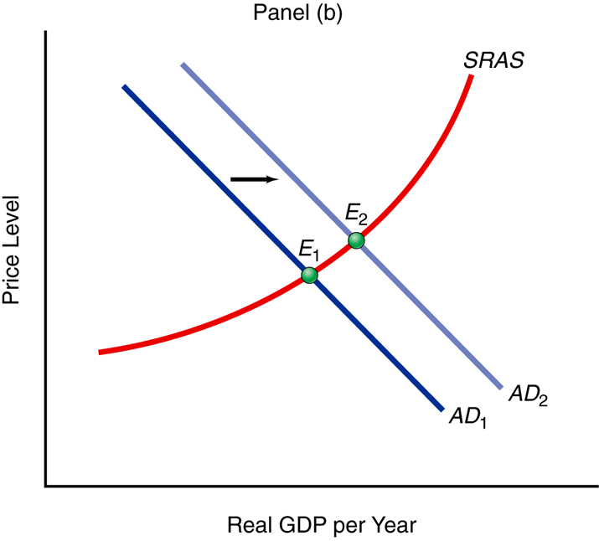

- If AD shifts left:
- Price level falls (inflation decreases) from P1 to P2
- Real GDP decreases from Q1 to Q2
- Unemployment increases
- Equilibrium moves down the SRAS curve

Shifting SRAS

- If SRAS shifts left:
- Price level rises from P1 to P2 (inflation increases)
- Real GDP decreases from Q1 to Q2
- Unemployment increases
- A “triple bad”
- Equilibrium moves up the AD curve
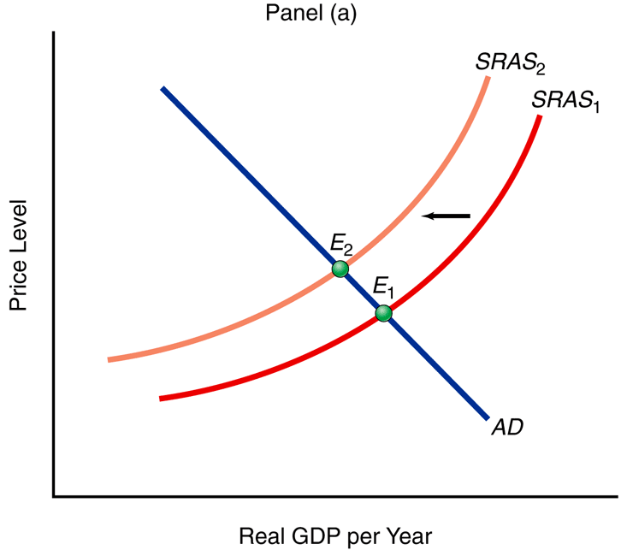

- If SRAS shifts right:
- Price level falls from P1 to P2 (inflation decreases)
- Real GDP increases from Q1 to Q2
- Unemployment decreases
- A “triple good”
- Equilibrium moves down the AD curve

Adding Long-Run Aggregate Supply (LRAS):

- LRAS is the goal of macroeconomics
- It is located at a GDP where there is:
- full-employment
- It is the maximum capacity the economy can produce without accelerating inflation
- Resources and technology are efficiently used. (None are idle)

- LRAS represents the same idea as the production possibility curve / production possibility frontier

- When long-run economic growth occurs:
- The production possibility curve pushes outward, and
- LRAS shifts right

Putting the Complete Model Together

- AD and SRAS can intersect and form a short-run equilibrium at:

A Recessionary Gap
- Real GDP less than Full-Employment GDP
- Buyers decrease their demand for goods; they now want to buy less than the productive capacity of the nation.
- Sales fall, then production falls.
- Unemployment rises.
- The economy goes into recession.

- Unemployment rate is higher than full employment.
- Inflation is not usually a problem
- an underperforming economy
- The economy is in equilibrium to the left of LRAS

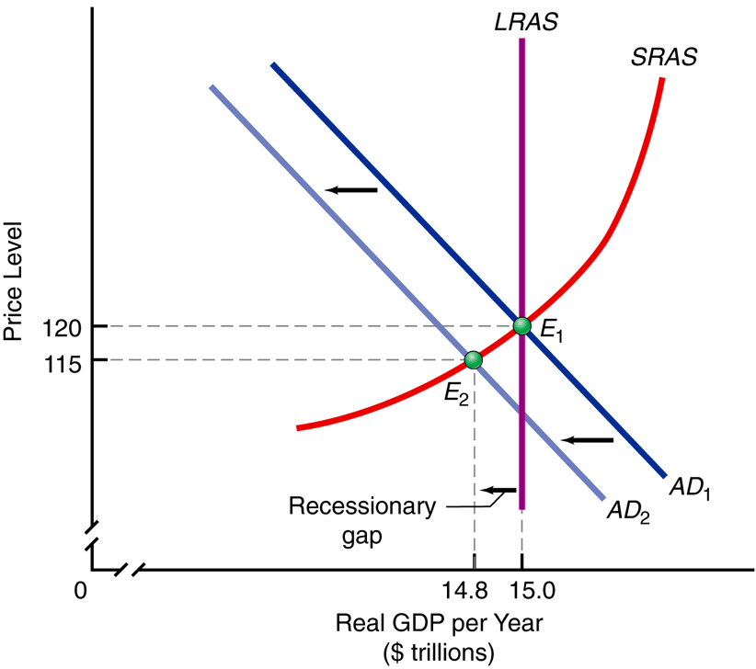

Using the SRAS curve to explain how Classical Economics views the economy will adjust to a recessionary gap.

- Economic participants take action to better themselves or to protect themselves.
- Self-regulation acts on the supply-side.
- Changes in incentive and in the capability to produce causes the SRAS to shift.

A Recessionary Gap -

- Caused by AD shifting too far left. – There is a surplus of goods & workers

- “Fixed” by SRAS shifting right
- Price level falls
- product prices fall
- wages fall
- Real GDP rises
- sales rise
- inventory depletes
- factory orders rise.
- production increases
- Unemployment falls
- firms hire more workers.
The recessionary gap is eliminated

An Inflationary Gap
- a Real GDP greater than Full-Employment GDP
- Eager buyers try to buy more than the economy can produce without accelerating inflation.
- Prices rise and inflation accelerates.
- Unemployment becomes abnormally low.
- Unemployment rate is lower than full employment
- Inflation is accelerating upward and is now the big problem
- an overheated economy
- The economy is in equilibrium to the right of LRAS

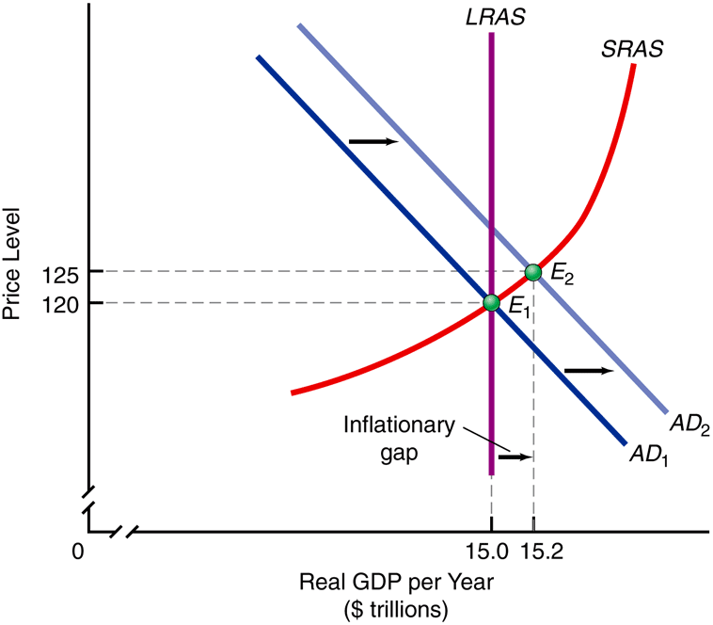

Using the SRAS curve to explain how Classical Economics views the economy will adjust to an inflationary gap.

- Economic participants take action to better themselves or to protect themselves.
- Self-regulation acts on the supply-side.
- Changes in incentive and in the capability to produce causes the SRAS to shift.

An Inflationary Gap -

- Caused by AD shifting too far right. – There is a shortage of goods & workers

- “Fixed” by SRAS shifting left
- Price level rises
- product prices rise
- wages rise
- Real GDP falls
- sales fall
- inventory increases
- factory orders fall.
- Employment falls
- wages rise
- some firms hire fewer workers,
- other firms lay off workers
The inflationary gap is eliminated

Full Employment
- a Real GDP equal to Full-Employment GDP
- Buyers want to buy exactly the amount for which the economy has a capability to produce.
- Inflation is under control.
- a full-employment economy
- The economy is in equilibrium at LRAS.

Types of Inflation:

Demand Pull Inflation – Inflation caused by increases in aggregate demand not matched by increases in aggregate supply (see graph of inflationary gap)

Cost Push Inflation – Inflation caused by decreases in aggregate supply

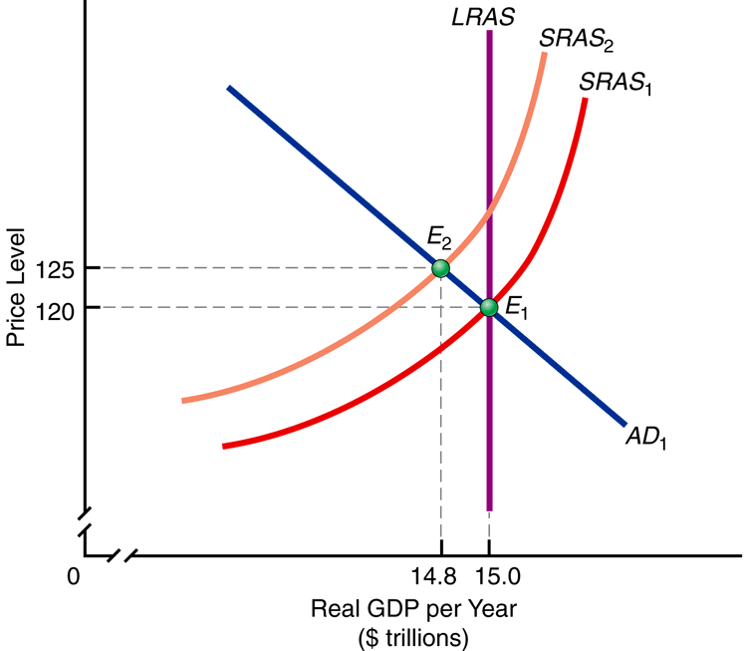

CONSUMPTION, REAL GDP, and the MULTIPLIER

Keynes felt that the key to increasing employment and there by improve the economy was to stimulate aggregate demand.

Definitions:

Real Disposable Income – The after-tax income of households (Real GDP minus net taxes). This is the funds household have to either spend or save.
Consumption – Spending of disposable income by households for new goods and services which will be used up.
Saving – The act by households of not consuming all of their current disposable income. Accumulated funds not spent are called savings.

Saving is a flow of funds. Savings is a stock of funds.

Keynes’ view of household consumption patterns ( the Keynesian Consumption Function)

- Consumption & Saving dependent on income. The level of real disposable income is the primary determinant of a household’s decisions on saving and consumption (in regards to saving, this differed from the Classical view which held that saving was tied to the interest rate.

New income (Y) after taxes (T), called disposable income (Yd), is divided into new spending (C) and new saving (S).
- Y = C + S + T
- Yd = Y – T = C + S
- ΔYd = ΔC + ΔS

- Dissaving - At low income levels households will consume more than their income . There is a negative saving

- Autonomous Consumption - There is a portion of household consumption which is independent of disposable income. This level of income exists at zero income.

- Marginal Propensity to Consume (MPC) – The ratio of the change in consumption to the change in disposable income (the percentage of each additional dollar in income which will be spent) MPC = ΔC / ΔYd
- Marginal Propensity to Save (MPS) – The ration of change in saving to the change in disposable income. (the percentage of each additional dollar in income which will be saved.) MPS = ΔS / ΔYd
- Changes in household Wealth (stock of assets) can shift the household consumption function.

NOTE: MPC + MPS = 1 (=100% of the change in income)

The Keynesian Consumption Function
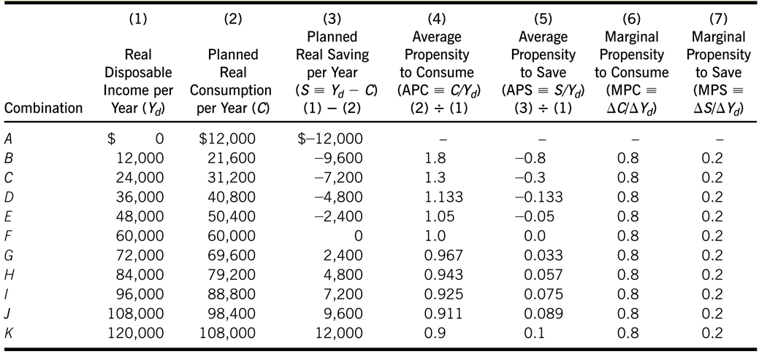

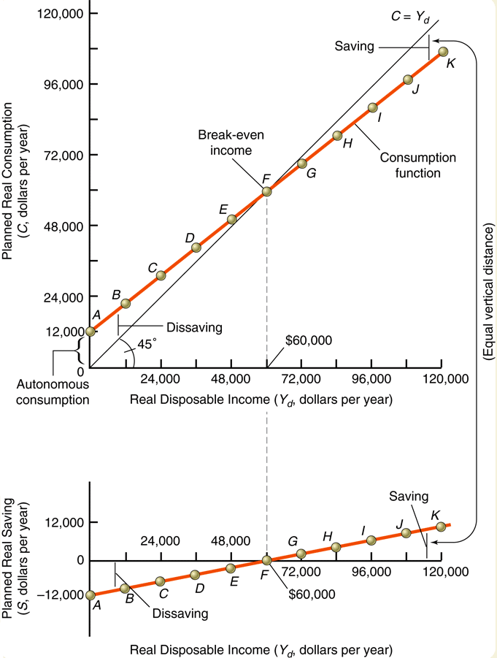

The 45degree line in graph 1 above represents the line of equality of Planned Real Consumption and Real Disposable Income. To simplify our model, we will substitute real GDP for real disposable income in the future.

Keynesian View of Investment

Investment – Business expenditures on
- capital equipment (machinery & facilities), to be used in the process to produce goods in the future.
- Business inventories of raw materials, goods in process, and finished products

The level of expenditures on Business Investment is more variable than that spent on household consumption.

The level of planned business investment is inversely related to the interest rate.
Keynesian Investment Function
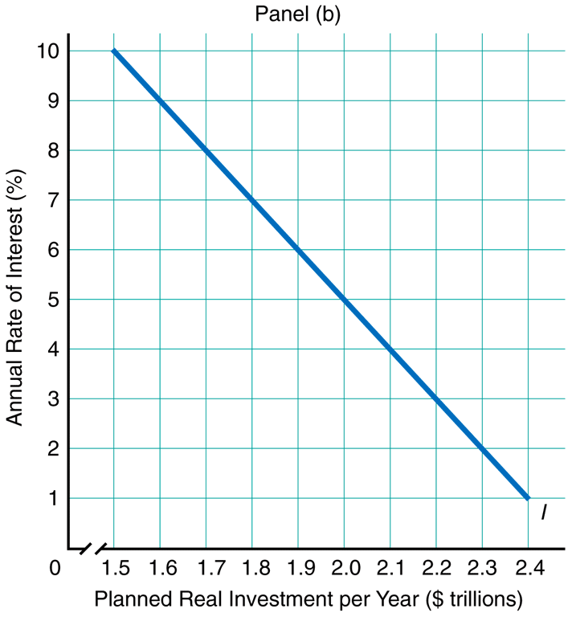

Factors which act to shift the investment function
- Profit expectations
- Higher profit expectation → shift Investment to the right
- Lower profit expectation → shift Investment to the left
- Improvement in productive technology → shift Investment to the right (increase expected profit potential from expenditures)
- Changes in business taxes (change expected profits from investment)
- Increase in business taxes → shift Investment to the left
- Decrease in business taxes → shift Investment to the right

Determining Equilibrium Real GDP

We add Investment to Consumption to arrive at the total planned private expenditures

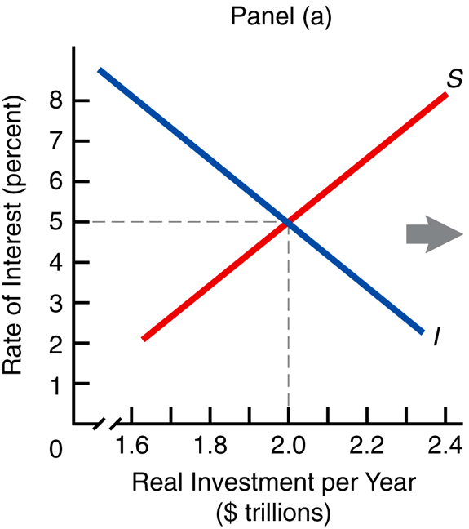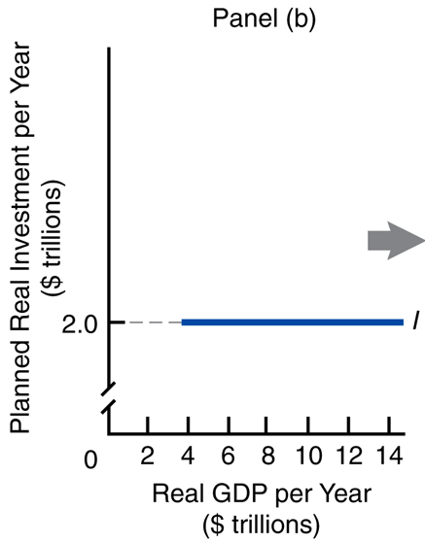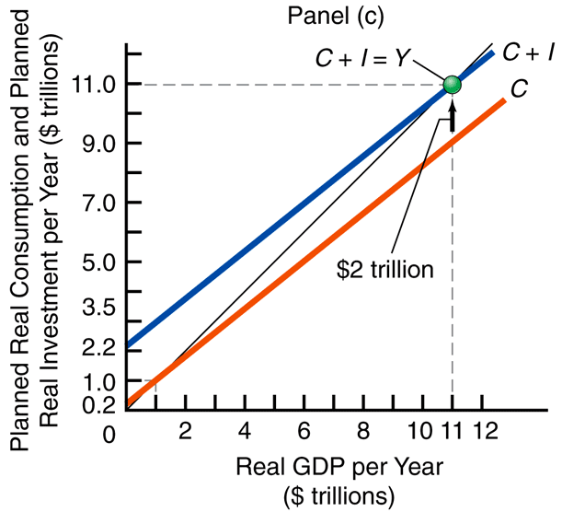
Equilibrium occurs when planned expenditures equals real GDP (real expenditures).

The Significance of Actual Savings and Investment not Equaling Planned Levels

Equilibrium in the aggregate economy will only occur when planned savings equals planned investment.

Whenever planned saving does not equal planned investment, the economy will experience unplanned changes in business inventory of finished goods.

Planned saving greater than planned investment
- If planned saving is greater than unplanned investment, there is less consumption than business expected.
- Unsold items increase business inventories (meaning that real business investment is great than planned investment).
- Business will react to this unplanned increase in inventory, by cutting back future production.
- There will be a lower future level of real GDP, and a lower level of employment.

Planned saving less than planned investment
- If planned saving is less than unplanned investment, there is more consumption than business expected.
- To meet the demand there will be an unplanned drawdown in business inventories (meaning that real business investment is less than planned investment).
- Business will react to this unplanned decrease in inventory, by increasing future production.
- There will be an increase in future level of real GDP, and a higher level of employment.

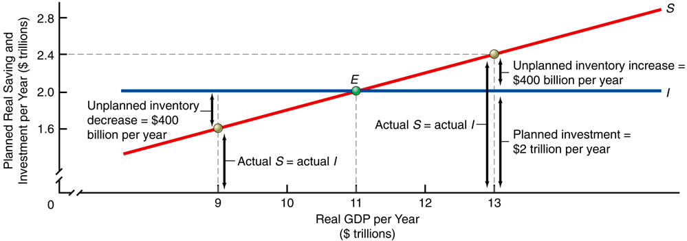

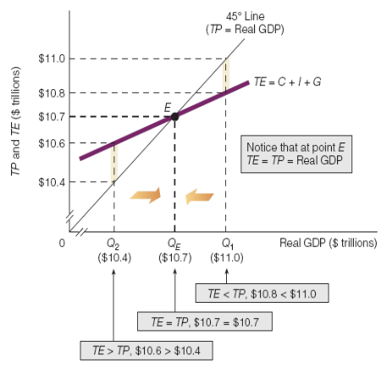

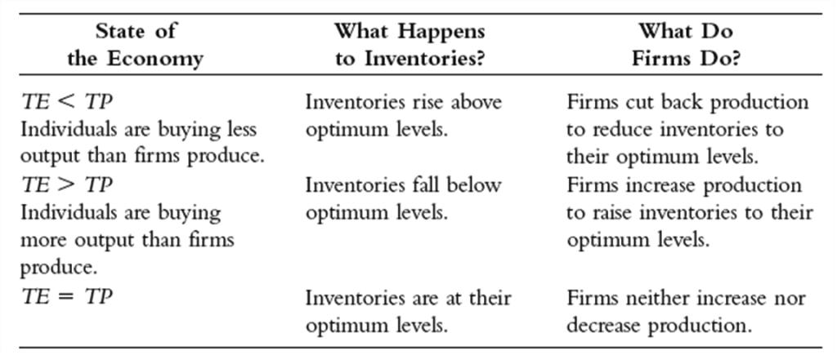

The Keynesian Multiplier

The Multiplier:
  - The number by which a change in autonomous real investment or autonomous real consumption is multiplied to get the change in equilibrium real GDP

Remember: Autonomous spending is any which is not dependent on the level of income.

Keynes’ Multiplier Effect
- A “jumpstart” in autonomous spending (possibly by government) will generate multiple rounds of spending throughout the economy
- Keynes showed that people are remarkably consistent on partitioning new after-tax income (Yd) into new spending (C) and new saving (S).
- In each cycle, part of the new income is set aside as saving (MPS).
- So, the next round of income-spending is smaller than the previous round.
- As new income grows, it ultimately reaches its maximum.
- The power of the multiplier effect is controlled by the size of MPS. It is an inverse relationship. The smaller the MPS, the larger the multiplier.

Spending multiplier = 1/MPS

Example below, the multiplier is 5 ( 1/MPS)

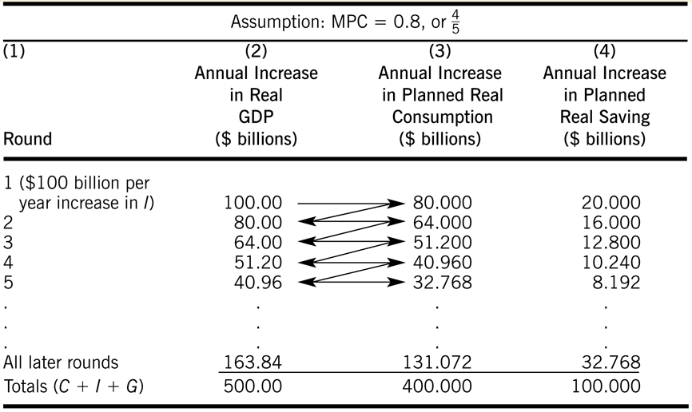

Be able to calculate the total change in spending and income due to any “jumpstart” in spending:

Considering Changes in the Price Level

The discussion above viewed the effects of the multiplier when the economy is experiencing a period of high unemployment with significant level of idle resources. The Short-Run Aggregate Supply (SRAS) curve is horizontal.

However, if the economy is in the upward segment of the SRAS curve the full effect of the multiplier will not transfer to Real GDP. Pressure on the general price level will lead to an increase in prices. (Real GDP will not increase by the full multiplier.)

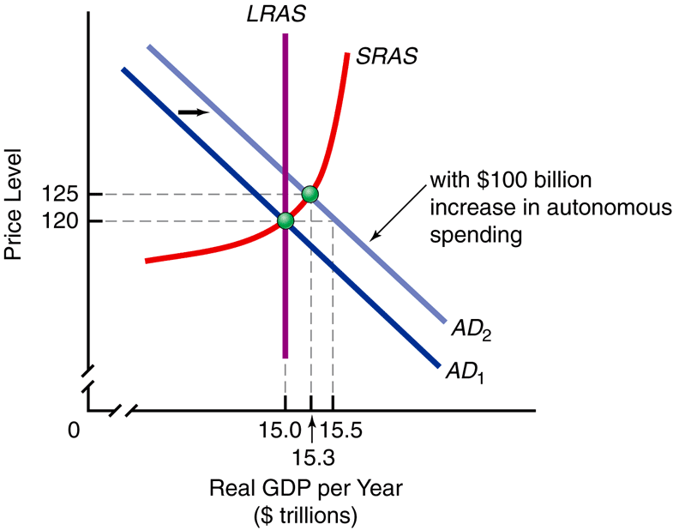

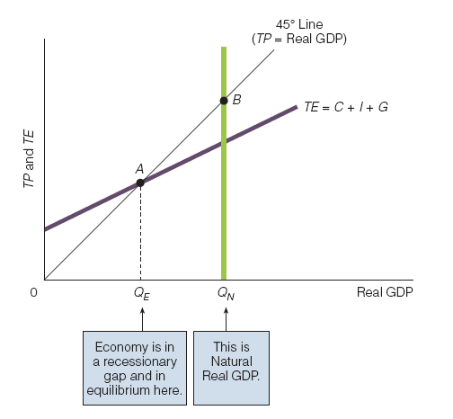

Is there a relationship between inflation and unemployment?

The Phillips Curve attempts to illustrate a trade off relationship between unemployment and inflation.

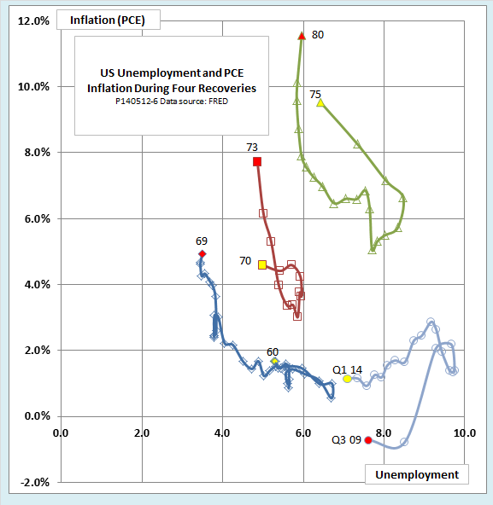

Hold up for prior business cycles, but not so well for the recent “Great Recession” and recovery.

